Ch En 477: Writing to a measurement File with Labview

Create Write to Measurement file loop
Now you will learn how to write the flow, pressure and temperature data to a measurement file. At this point your block diagram should look something like what is shown on the next page: (It is not intended that you copy the front panel indicators. The indicators pictured here are not likely to be used for this application. They are intended to be place holders, allowing you to learn the idea and then apply it to your system.)
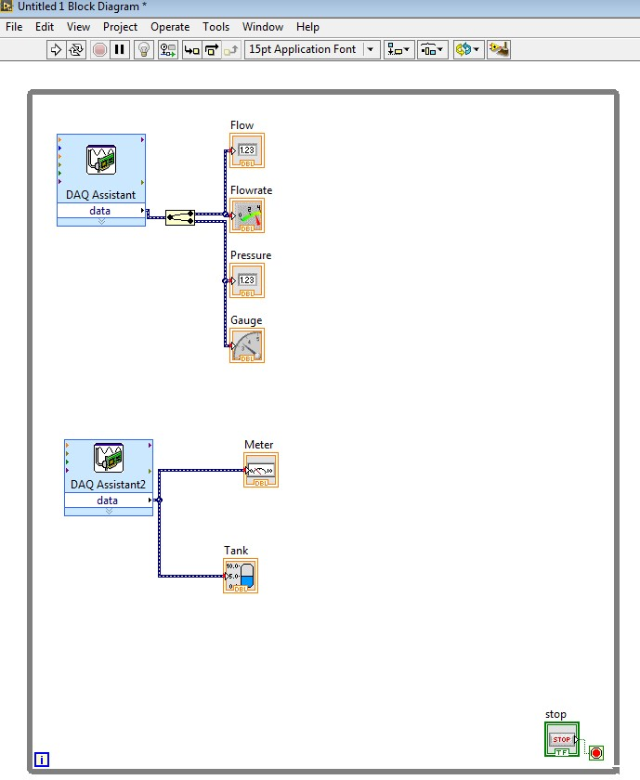
- Add a case structure loop to the right of the temperature DAQ Programming >>Structures>>Case Structure
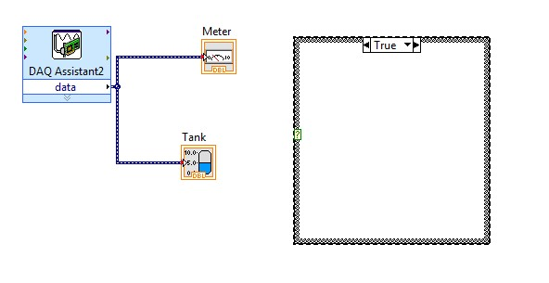

- Right click the green question mark of the case structure and select Create Control. This will create an on/off Boolean switch in the front panel with a corresponding figure wired to the loop, which can be retitled as appropriate.
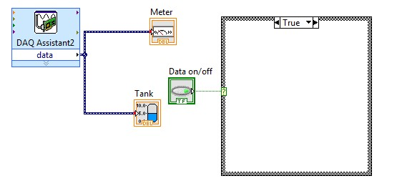

- Place a write to measurement file inside the case structure Programming>>File I/O>>Write Meas F..
- Choose parameters for the file. The ones chosen as follows allow for new data to be appended or added each time data is written saved in an Excel file with one time column. It is recommended that the file be saved on the students J:\ drive. Click OK. The block diagram should look as on the next page.
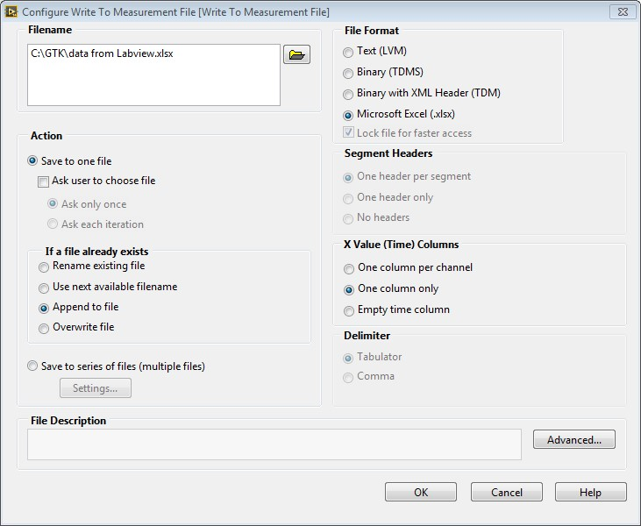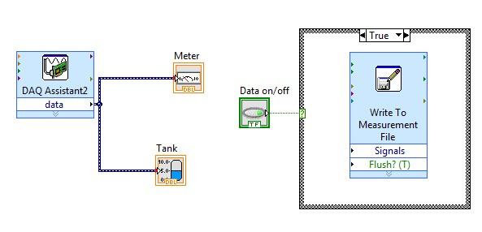

- Now connect the data channels from both DAQs to the signals input on the write to measurement file using a merge signals found in Express>>Sig Manip>> Merge Signals. The lines should be branched, meaning the wire spool cursor should be held over the wire until it is blinking and then clicked. On the flow/pressure DAQ the line should be taken before the split signal. It will look something like below:
